Reach for the Stars

****Promoting High Quality child care

The North Carolina

Child Care Health Consultant

2024 Annual Conference

September 24 and September 25, 2024

Hickory Metro Convention Center

1960 13th Av. Drive SE, Hickory, NC 28602

Tuesday, September 24th

9:30 AM Sign-in *(sessions will be in Conover 1 unless otherwise specified)*

10:00 AM **Welcome:** Jacquie Simmons and Julie Daniels, NC Resource Center

10:15 AM **Session I:** Angela Lewis, NC Partnership for Children

11:15 PM Break and Networking

11:30 AM **Session II:** W. David Brown, Environmental Health Section

12:30 PM Lunch, Conover 4

1:30 PM **Session III:** Megan Porter, North Carolina Rated License Assessment Project

2:30 PM **Session IV:** Virginia C. Stage, NC State University / NC State Extension

3:30 PM Break and Ice Cream Social

4:00 PM **Keynote Address:** Rhodus Riggins, UNC-Greensboro

5:00 PM Optional Wellness Session – Ellie Morris

|  |  |
| --- | --- |
| Session I  10:15 – 11:15 AM  NC Partnership for Children Update  Angela Lewis – Early Care and Education Manager  This session will present an update of current information related to Smart Start funded CCHC activities. The audience will be engaged in discussion as well as a question-and-answer period. | Session II  11:30 – 12:30 PM  Child Health and Safety is Everyone’s Responsibility  W. David Brown – Surveillance Coordinator, REHS, Division of Public Health, Environmental Health Section,  North Carolina Department of Health and Human Services  Join David and fellow CCHCs in another engaging discussion. This presentation will provide pictures and discussion to increase awareness of potential health and safety hazards in child occupied facilities. |
| Session III  1:30 – 2:30 PM  Common Questions about the ITERS-R and NCRLAP assessments  Megan Porter – NCRLAP State Anchor,  North Carolina Rated License Assessment Project (NCRLAP)  This session will cover information related to specific requirements of the ITERS-R. We will discuss common challenges and provide NCRLAP resources that demonstrate ways to prepare for the assessment process. There will also be time to answer questions regarding the assessment process and the Environment Rating Scales. | Session IV  2:30 – 3:30 PM  Making “Sense” of Mealtime Challenges: Inclusive Strategies for Supporting Teachers and Families with Food-Sensitive Children  Virginia C. Stage, PhD, RDN – Nutrition Education & Behavior Specialist / Assistant Professor,  North Carolina State University / NC State Extension  “If they are hungry enough, they will eat.”  But what if children refuse to eat or insist on eating the same food repetitively? This presentation will discuss how challenging feeding behaviors often involve sensory or skill-based issues. Participants will learn strategies that can be used to support teachers and families interested in turning their food-sensitive child into an adventurous eater. |

Keynote Speaker

*Rhodus Riggins, Quality Enhancement Coordinator, Education Quality Improvement and Professional Development Project at the University of North Carolina-Greensboro*

GET BACK!

The quest for quality and competing demands on our time, energy, and emotional reserves influence how we show up. Let’s get back to us and the voices and experiences of the human beings in and behind our work. Let’s get back to our true essence, how we be, grow with self, and others.

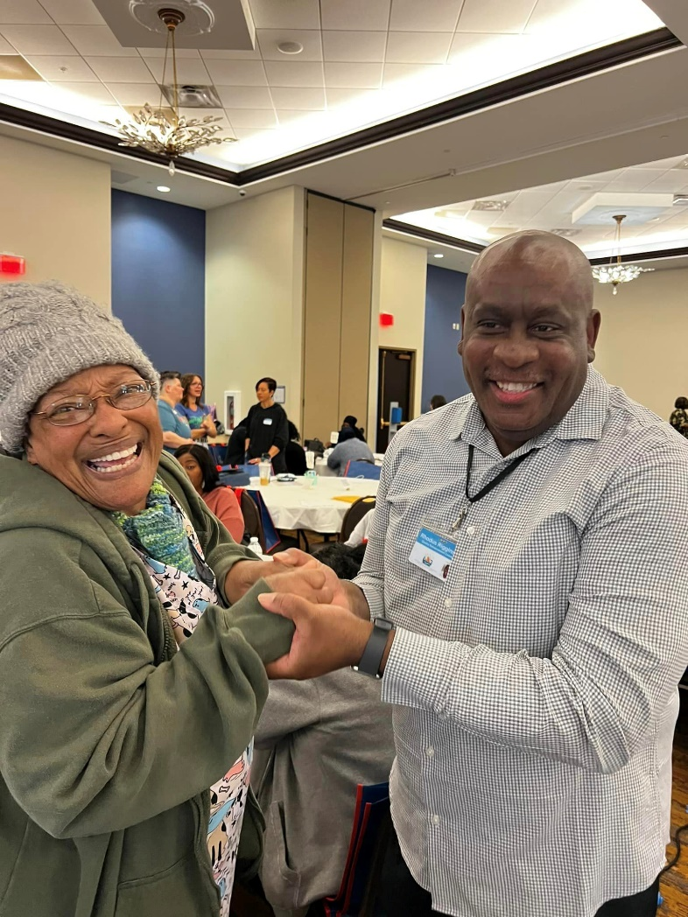Rhodus Riggins, Jr. is Quality Enhancement Coordinator at the Education Quality Improvement and Professional Development Project (EQuIPD) at the University of North Carolina- Greensboro. He is Adjunct Faculty member at Alamance Community College and UNC-Greensboro. He is co-founder and co-owner of Bailey, Pullis, & Riggins LLC, a racial equity consulting organization.

Rhodus is a grassroots advocate and early childhood champion from the Low Country region of South Carolina. He holds a M.Ed. in Educational Leadership, Public Policy, & Advocacy in Early Childhood.

Wednesday, September 25th

6:15 AM Optional Group Morning Walk – Alicia Tanner

8:30 AM Breakfast, Sign-in, and Welcome *(sessions will be in Conover 1 unless otherwise specified)*

9:00 AM Annual CCHC Meeting and Elections, Nicole Richardson, NC CCHCA Chair

10:00 AM Recognition of New CCHCs

10:15 AM Break and Networking

10:30 AM Breakout Sessions:

1. “Supporting Children with FASD: Strategies for Educators”, Conover 2
2. “Common Chemicals in Homes and Child Care: Understanding Phthalate Exposure and Steps to Protect Children”, Conover 1
3. “NC CCR&R Family Child Care Project: Building and Sustaining NC Family Child Care Programs”, Conover 3

12:00 PM Wrap-Up, Evaluations

12:30 PM Adjournment

*Breakout Session Descriptions*

“Supporting Children with FASD: Strategies for Educators”, Conover2

Lauren Borchert, Proof Alliance NC Program Manager, The Arc of North Carolina

This interactive session will help participants understand the impact of prenatal alcohol exposure on the developing fetal brain, recognize characteristics of fetal alcohol spectrum disorders (FASD), as well as understand strategies for support and the role we all play in preventing alcohol exposed pregnancies and supporting those with FASD.

“Common Chemicals in Homes and Child Care: Understanding Phthalate Exposure and Steps to Protect Children”, Conover 1

Neasha Graves, MPA, Environmental Health Outreach Manager, UNC Center for Early Life Exposures and Neurotoxicity (UNC CLEAN)

Phthalates are chemicals added to plastic and personal care products, with as much as 470 million pounds sold in the US each year. In this interactive session, we will explore how children are exposed to these chemicals in child care centers and homes, the impact on children’s health, and steps for reducing exposure and protecting their health.

“NC CCR&R Family Child Care Project: Building and Sustaining NC Family Child Care Programs”, Conover 3

Daniel Bates, Statewide Family Child Care Project Manager, NC CCR&R Statewide Family Child Care Project/Southwestern Child Development Commission

Vickie Ansley, Southwestern Child Development Commission

This session explores the NC Statewide CCR&R Family Child Care Project, its key components, current initiatives, and the role of regional family child care consultants. It also discusses collaboration with the Health and Safety Center to ensure North Carolina's children receive the best care.

Wrap Up, Evaluation, and Safe Travels!

*Thank you to our Conference Planning Committee members for their hard work!*

*Dee Bullock*

*Kristey Coulter*

*Tamara Dempsey-Tanner*

*Julie Johnson*

*Sharleen Laporte*

*Amy Matthews*

*Lindsey Pertet*

*Stacy Rosser*

*Courtney Summey*

*Alicia Tanner*

*Jasmine Walker*

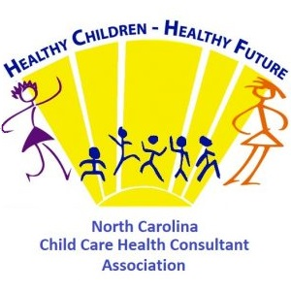*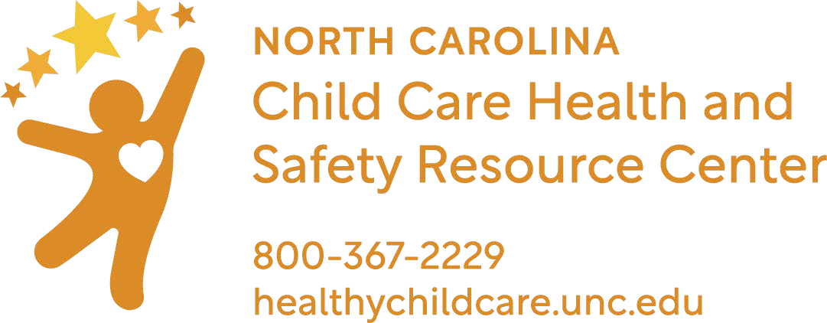The Annual NC Child Care Health Consultant Conference is sponsored by:*